Unit 2: Nuclear & Atomic Structure AP Chemistry

Chapter 2.1 The Atomic Theory of Matter

- Democritus (460-370 BC) – named atoms. Thought all matter was made of tiny indivisible particles.
- John Dalton: Between 1803-1807 developed the 1st atomic theory.
  - Each element is composed of tiny particles called atoms.
  - All atoms of an element are identical to another in mass and properties but are different from other elements.
  - Atoms of one element can NOT be changed into atoms of different elements by chemical means, nor can they be created or destroyed in a chemical reaction.
  - Compounds are formed when atoms of more than one element combine, and the compound always has the same number of atoms and kind of atoms.
- Atoms are the smallest particles of an element that retains the properties of the element.
- Fundamental Chemical Laws:
  - Law of Definite Proportions: aka law of constant composition: A given compound always contains exactly the same proportions of elements by mass.
  - Law of Conservation of Mass: aka law of conservation of matter: matter cannot be created or destroyed in a chemical reaction, just rearranged.
  - Law of Multiple Proportions: if elements of A and B combine to form a compound, the masses of B that combine with a given mass of A are in the ratio of small whole numbers.
    - Dalton considered the compounds of Carbon & Oxygen and found:

Mass of Oxygen that Combines with 1 gram of Carbon
Compound I | 1.33 g
Compound II | 2.66 g

Therefore compound I may be CO and compound II may be CO₂

Exercise 2.1 Illustrating the Law of Multiple Proportions

The following data was collected for several compounds of Nitrogen and Oxygen. Show how this data illustrates the law of multiple proportions.

Mass of Nitrogen that Combines with 1 gram of Oxygen
Compound I | 1.750 g
Compound II | 0.8750 g
Compound III | 0.4375

Chapter 2.2 The Discovery of Atomic Structure

- Problem 1 with Dalton’s theory: atoms are be broken down into smaller particles, called subatomic particles.
- Charged particles: like particles repel, unlike particles attract
- The Electron
  - JJ Thompson, English, between 1898-1903 found that when high voltage was applied to an evacuated tube, a “ray” he called a cathode ray was produced.
    - The ray was produced from the (-) electrode (cathode)
    - Repelled by the (-) pole of the applied magnetic field, E
    - He proposed that the stream was NEGATIVE particles we now call electrons.
    - Results did not change, no matter what material was used for the cathode.

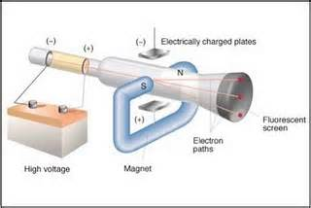

- Thompson then measured the deflection of beams of the e- to determine the charge-to mass ration
e = -1.76 x 10⁸ C e= charge
m g m= mass
C= coulomb (unit for electric charge)

- Thompson also determined that all atoms were neutrally charged overall. His model was called the plum pudding model.
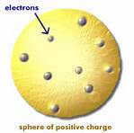
- Robert Millikan, American, 1909, performed a series of experiments called Millikan’s Oil-Drop experiment.
  - Sprayed charged oil drops into an chamber
  - Halted their fall due to gravity by applying voltage across 2 plates
  - Measured the voltage need to halt the falling drops and the mass of the oil drop
  - Used this to calculate the mass of the electron with Thompson’s charge to mass ratio
  - Charge of electron: 1.602 x 10⁻¹⁹ C
  - Mass of an electron: 9.10938 x 10⁻²⁸ g

- Radioactivity: spontaneous emission of high-energy radiation.
  - Discovered by Henry Becquerel, French when studying Uranium
  - Ernest Rutherford, British revealed 3 types of radiation
    - Alpha α : equivalent to a helium nucleus, the largest radioactive particle emitted, 7400 times the mass of an e-, attracted to negative charge
    - Beta β : a high speed electron, attracted to positive charges
    - Gamma γ : pure energy, no particles at all, no charge

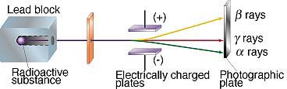

- The Nuclear Atom: Discovery of the Nucleus
  - Rutherford’s Gold Foil experiment, 1910
    - Tested Thompson’s Plum Pudding model
    - Directed alpha particles at a thin sheet of gold foil
    - Expected all alpha particles to pass through without some minor deflections
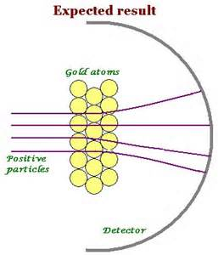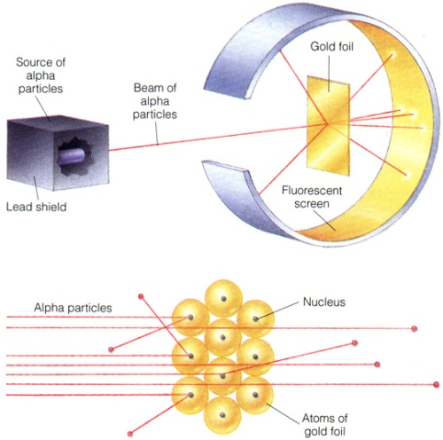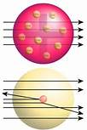

  - Results were not what was expected:
    - Most alpha particles did pass straight through, BUT many were deflected at LARGE angles and some were even reflected.
    - Plum Pudding model could not be correct.
    - Particles deflected had a close encounter with a positive center of the atom
    - Particles reflected had hit the positive center directly
    - Rutherford concluded the atoms had a (+) charged core, or nucleus

  - Protons discovered in 1919 by Rutherford

  - Neutrons discovered in 1932 by James Chadwick

Chapter 2.3 The Modern View of Atomic Structure

- Elements: all matter composed of only one type of atom is an element. There are 92 naturally occurring elements, all others are manmade.
- Atoms: the smallest particle of an element that retains the properties of that element.
  - Nucleus: contains protons & neutrons
  - Protons: positive charge, determine the identity of the element, same as the atomic number
  - Neutrons: no charge, same size and mass as the proton, responsible for isotopes, alters the mass number.
  - Electrons: negative charge, same size as the proton/neutron but 1/1836 the mass of proton/neutron responsible for bonding & atomic behavior

Particle | Mass | Relative Mass | Charge | Relative Charge | Location
p⁺ | 1.67 x 10⁻²⁷ | 1 (1.0073 amu) | +1.602 x 10⁻¹⁹ C | 1+ | Nucleus
n⁰ | 1.67 x 10⁻²⁷ | 1 (1.0073 amu) | 0 | 0 | Nucleus
e⁻ | 9.11 x 10⁻³¹ | 0 (5.486 x 10⁻⁴ amu) | -1.602 x 10⁻¹⁹ C | 1- | Electron Cloud

- Atomic Number (Z): The number of protons in an atom. All atoms of the same element have the same number of protons.
- Mass Number (A): The sum of an atoms protons and neutrons. A different mass number does NOT mean a different element, just an isotope of the same element.
- Atomic Notation:
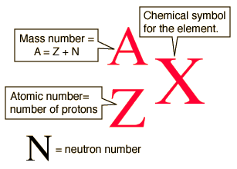

Exercise 2.2 Determining the Number of Subatomic Particles in Atoms

How many protons, neutrons, and electrons are in (a) an atom of ¹⁹⁷Au (b) an atom of strontium-90?

Exercise 2.3 Writing Symbols for Atoms

Write the complete chemical symbol for the atom that contains 82 protons, 82 electrons, and 126 neutrons.

- Isotopes: atoms that have the same atomic number (# of p+) but a different number of neutrons.
  - Most elements have at least two stable isotopes, there are very few with only one stable isotope (Al, F, P)
  - Hydrogen isotopes are so important, they have special names.
    - 0 neutrons hydrogen
    - 1 neutron deuterium
    - 2 neutrons tritium

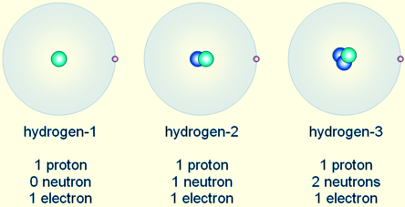

Chapter 2.4 Atomic Weights

- Average Atomic Mass (aka atomic weight): an average of an elements isotopes weighted by their percent abundance found in nature.
  - This is the atomic mass found on the Periodic table for each element.
Exercise 2.4 Calculating the AAM of an Element

Naturally occurring chlorine is 75.78% Chlorine-35, which has a mass of 34.969 amu, and 24.22% Chlorine-37, which has a mass of 36.966 amu. Calculate the average atomic mass of chlorine.

Chapter 6.1 The Wave Nature of Light

- Electronic Structure: use of the quantum theory to describe arrangements of electrons in atoms.
- Visible light is a form of electromagnetic radiation or radiant energy
  - Radiation carries energy through space.
  - Electromagnetic energy is characterized by its wave nature.
- Waves:
  - Wavelength (λ): length between two successive crests
  - Frequency (υ): number of cycles per second that pass a certain point
    - Hertz (Hz): unit for frequency = cycles/second or sec⁻¹
  - Amplitude: maximum height of a wave as measured from the axis of propagation
  - Nodes: points of zero amplitude (equilibrium position)
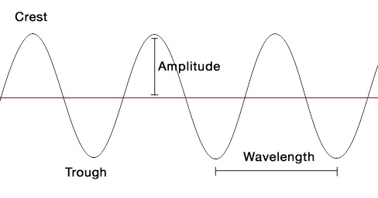

- The speed a wave: Velocity = wavelength x frequency
  - The speed of light (c) = 3.00 x 10⁸ m/s
  - ALL ELECTROMAGNETIC RADIATION TRAVELS AT THE SPEED OF LIGHT.
  - Wavelength & frequency are inversely proportional to each other.

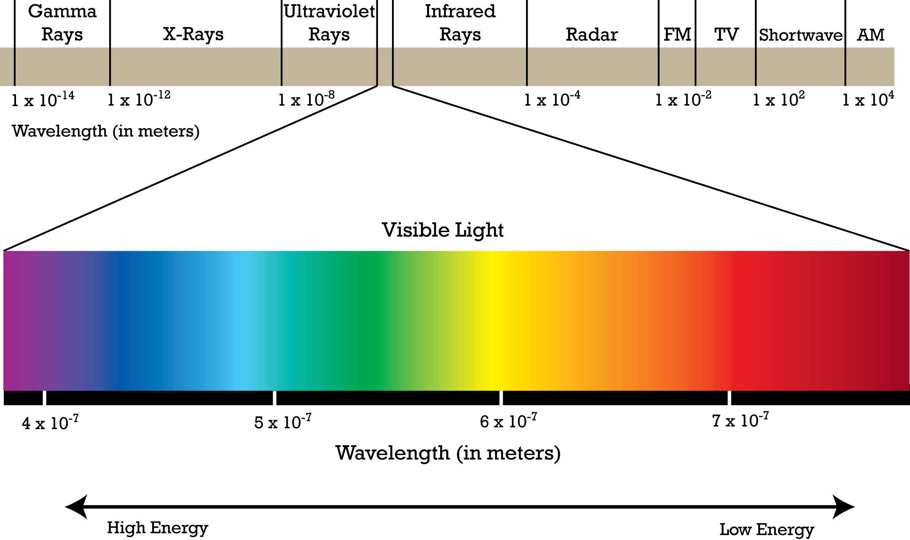
Exercise 6.1 Frequency of Electromagnetic Radiation

The brilliant red colors seen in fireworks are due to emission of light with wavelengths around 650 nm when strontium salts such as Sr(NO₃)₂ and SrCO₃ are heated. Calculate the frequency of red with the wavelength 6.50x10² nm.

- The electromagnetic spectrum is a display of various types of electromagnetic radiation arranged in order of increasing wavelength.
  - Visible light has wavelengths between 400nm (violet) and 750nm (red)

6.2 Quantized Energy and Photons

- Some phenomena can’t be explained using the wave model of light:
  - Blackbody radiation is the emission of light from hot objects.
  - The photoelectric effect is the emission of electrons from metal surfaces on which light shines.
  - Emission spectra are the emissions of light from electronically excited gas atoms.
- Hot Objects and the Quantization of Energy
  - Heated solids emit radiation (black body radiation)
    - The wavelength distribution depends on the temperature
      - Red hot objects are cooler that white hot objects
  - Max Planck (1900) investigated black body radiation.
    - Proposed that energy can only be absorbed or released from atoms in certain amounts (quanta).
    - A quantum is the smallest amount of energy that can be emitted or absorbed as electromagnetic radiation.
    - The relationship between energy and frequency is: ΔE=n(hυ)
      - h is Planck’s constant (6.626 x 10⁻³⁴ J-s)
      - n= cannot be fraction, whole number of quanta only hv, 2hv, 3hv…
- The Photoelectric Effect and Photons
  - The photoelectric effect provides evidence for the particle nature of light.
  - Einstein assumed that light traveled in energy packets called photons.
    - Energy of a photon E_{photon}= hυ
  - Light shining on the surface of a metal can cause electrons to be ejected from the metal.
    - Below threshold frequency- no e- ejected.
    - Above threshold frequency- excess energy appears as the kinetic energy of the ejected electrons.
  - Light has wave-like AND particle-like properties called the dual nature of light.

Exercise 6.2 The Energy of a Photon

The blue color in fireworks is often achieved by heating copper (I) chloride to about 1200 ˚C. Then the compound emits blue light having a wavelength of 450 nm. What is the increment of energy (the quantum) that is emitted at 4.50x10² nm by CuCl?

6.3 Line Spectra and The Bohr Model

- Spectrum: produced when radiation containing from a source is separated into its different wavelengths.
  - Continuous spectrum: rainbow of colors containing all wavelengths
  - Line spectrum: containing only specific wavelengths
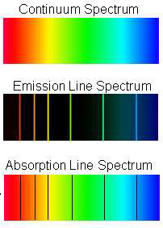

- Bohr’s Model:
  - Rutherford assumed that electrons orbited the nucleus like planets orbit the sun.
    - However, a charged particle moving in a circular path should lose energy.
    - This means the atom should be unstable according to Rutherford’s theory.
  - Bohr noted the line spectra of certain elements and assumed that electrons were confined to specific energy states. These were called orbits.
  - Bohr’s model had three postulates:
    - Only orbits of specific radii, corresponding to certain magnitude of energy, are permitted for electrons in an atom.
    - An electron in a permitted orbit has a specific energy and is an “allowed” energy state.
    - Energy is only emitted or absorbed by an electron as it moves from one allowed energy stated to another.
      - Energy is gained or lost as a photon

- Energy States of the Hydrogen Atom:
  - Colors from excited gases arise because e- move between energy states in an atom
  - Since the energy is quantized, the light emitted from the atoms must be quantized and appear line spectra.
  - The first orbit in the Bohr model has n=1 closest to the nucleus.
  - The furthest orbit has n= ∞ and E=0
  - Electrons in the Bohr model can only move between orbits by absorbing and emitting energy in quanta (E=hυ)
    - Ground state is the lowest energy level
    - A higher energy level is an excited state.

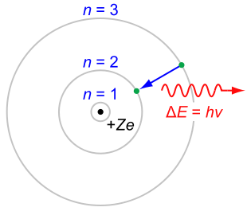
- Limitations to the Bohr Model
  - It cannot explain the spectra of atoms other than hydrogen
  - Electrons do not move about the nucleus in circular orbits.
  - Important contributions:
    - Energy of an electron is quantized: the only exist in certain energy levels
    - Energy loss or gain is involved in moving an electron from one energy level to another.

6.4 The Wave Behavior of Matter

- Dual nature of light- wave and particle (photon) like qualities. Does matter have wave-like qualities?
- Answered by Louis deBroglie:
  - Derived from Einstein’s and Planck’s equations: λ = h/mv (m= mass, v= velocity, mv= momentum)
  - Momentum is a particle property, λ is a wave property/
  - Applies to low-mass, high-speed objects.
  - Proved experimentally with x-ray diffraction and electron microscopy.
- Heisenberg’s uncertainty principle: we cannot know the exact position , direction of motion, and speed of a subatomic particle simultaneously.

6.5 Quantum Mechanics and Atomic Orbitals

- Shrodinger proposed an equation that contained both wave and particle terms.
- Uses advanced calculus – leads to wave functions Ψ
  - Describes the electron’s matter wave
    - Square of the wave function Ψ² gives the probability of finding an electron (electron density)
- Electron density is another of expressing probability.
  - A region of high electron density is one where there is a high probability of finding an e-.

Orbitals & Quantum Numbers
- We call the wave function Ψ orbitals.
- Quantum Numbers:
  - n: principal quantum number
    - same as Bohr’s n
    - = to energy level
    - As n becomes larger, the e- is further from the nucleus
  - l: angular momentum quantum number
    - value of l= begin a 0, end at n-1
    - refer to the s, p, d, f orbitals
    - defines the shape of the orbital
  - m_{l}: magnetic quantum number
    - depends on l (-1 to l)
    - defines the 3D orientation of the orbital
- A collection of orbitals with the same value of n is called an electron shell.
  - Number of orbitals in an electron shell = n²
    - n=3, there are 9 orbitals
- A set of orbitals with the same n and l are called a subshell.

Orbitals:
