**Name:___________________**

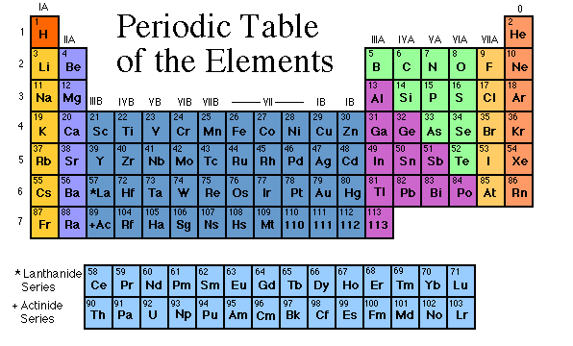**Periodic Table**

**Internet Investigation**

**Instructions: In each of the websites listed, find the information asked for.**

**“Family Fun”**

**Go to** [**http.//chemicalelements.com/**](http://www.chemicalelements.com)

1. Click on Alkali Metals (left bar) and answer the following questions.
2. What is the group number?
3. Are these metals reactive?
4. Do these metals occur freely in nature?
5. How many electrons are in their outer shell?
6. What are the three characteristics of ALL metals?
7. Are these metals soft or hard?
8. Name the two most reactive elements in this group?
9. What happens when they are exposed to water?
10. Click on Alkaline Earth Metals (left bar) and answer these questions.
11. What is the group number?
12. Are these metals reactive?
13. Do these metals occur freely in nature?
14. How many electrons are in their outer shell?
15. Click on Transition Metals (left bar) and answer these questions.
16. How many elements are in this group?
17. What are the group numbers?
18. What are valence electrons?
19. Because the valence electrons are present in more than one _____________ transition metals often exhibit several common __________________.
20. Name the three elements in this family that produce a magnetic field.
21. Click on Other Metals (left bar) and answer these questions.
22. How many elements are in this group?
23. What are the group numbers?
24. How are these other metals similar to the transition metals?
25. How are these metals different than the transition metals?
26. List three physical properties of these other metals.
27. What are the oxidation numbers for this group?
28. Click on Metalloids to answer these questions.
29. Metalloids have properties of both ________ and _____________.
30. Define semiconductor
31. Name two metalloids that are semi-conductors.
32. This property makes metalloids useful in ____________and _____________.
33. Click in Nonmetalsto answer these questions**.**
    1. What are the group numbers?
    2. List four characteristics of ALL nonmetals.
    3. What two states of matter do nonmetals exist in at room temperature?
    4. The nonmetals have no _______________and do not ________________.
    5. What are the oxidation numbers of the nonmetals?
34. Click on the Halogens(left bar) to answer these questions**.**
    1. What is the halogen group number?
    2. Are halogens metals or nonmetals?
    3. The term “halogen” means ____________________ and compounds containing halogens are called ____________________.
    4. How many electrons are in their outer shell?
    5. What is their oxidation number?
    6. What states of matter do halogens exist in at room temperature?
35. Click on Noble Gases(left bar) and answer these questions**.**
    1. What is the group number?
    2. Why were these gases considered to be inert or stable?
    3. What is their oxidation number?
36. Click on Rare Earth Elements (Inner Transition)(left bar) and answer thesequestions.
    1. How many Rare Earth elements are there?
    2. Define trans-uranium.
    3. The Rare Earth metals are found in group _______________and periods ______________and _______________.

**Metals, Non-metals, Metalloids**

**Go to** <http://www.mikeblaber.org/oldwine/chm1045/notes/Periodic/Metals/Period06.htm>

**Properties of Metals:**

1. Malleable (define)
2. Ductile (define)
3. _______________ ionization energy
4. _______________ electrons to form ____________
5. Forms _________________ compounds with non-metals
6. All metals are ______________________ at room temperature except for __________ which is a liquid.
7. Good conductors of ______________ and _________________

**Properties of Non-Metals:**

1. Non-lustrous
2. __________________ conductors of heat and electricity
3. Define diatomic molecule. Name the 7 diatomic molecules.
4. ________________ electrons forming ________________
5. When bonded with metals forms a _______________ compound
6. When bonded with other non-metals forms a _________________ compound

**Properties of Metalloids:**

1. Has similar properties to both ________________ and ___________________
2. Silicon: describe the properties & use of silicon.

**Trends in Metallic Character:**

1. Describe the trend in metallic character on the periodic table.
2. What element has the most metallic character?
3. What element has the least metallic character?