Name:
ELECTRICITY FROM THE BRAIN
Instructions: (1.) Carefully read the text and study the diagram. (2.) Use the diagram and what you have read to help you to answer the questions.
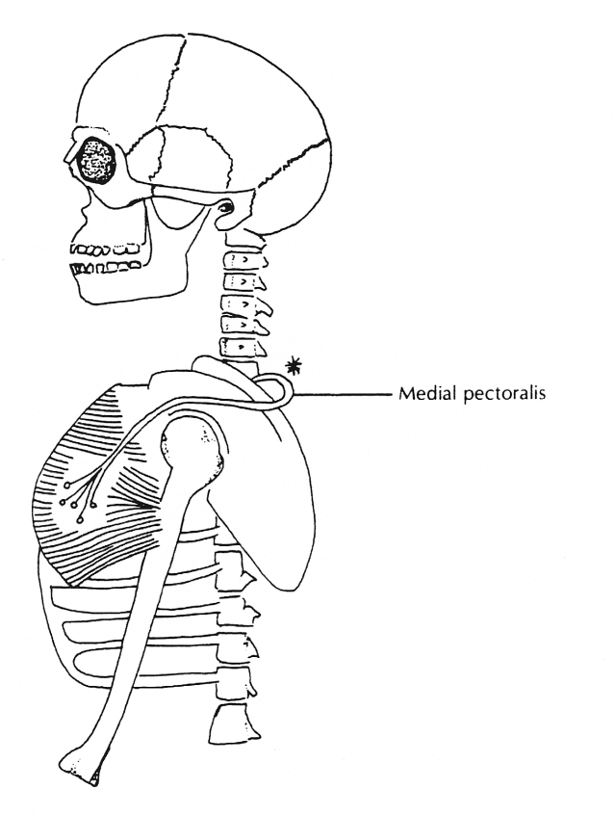

The muscles that move your skeleton are voluntary muscles, or muscles that are under your conscious control. You can stand up or sit down or swing your foot or wave your hand or do thousands of other things with your voluntary muscles.
Most of the time, of course, you don't think about it; you just wave, for example, without thinking, "I believe I'll use my muscles and tendons to move my hand and arm." But you can do it consciously.
In either case, your brain sends electrochemical signals to your muscles. These signals, which are similar to electricity, leave your brain through a large cable like structure called the "spinal cord"; they travel a short distance through it before leaving through branches called "nerves." The nerves direct the signals to the muscles that move your arm, hand, and shoulder. When these signals arrive, the appropriate muscles contract and your hand and arm moves, as you want them to.
You are undoubtedly aware that some muscles in your body are not under your voluntary control; these are the involuntary muscles. Here are a few examples of what your involuntary muscles do: They cause your stomach to contract, control movements in your intestines, make your heart pump, constrict your arteries to increase blood pressure, and cause the hair on your arm to stand up when you get goose bumps. Because the structure and function of your involuntary muscles are different from those of your skeletal muscles, your teacher will mention them in other units.
Level One Questions:
- The muscles that move your skeleton are ______________________________ muscles.
- What does the term voluntary mean?
- What does your brain do when you want to wave your hand?
- Electricity leaves the brain through a cable-like structure called the ____________ cord.
- What is the job of the nerves?

- What happens after the electricity reaches the muscles?
- The diagram shows a nerve leaving the spinal cord. What is the name of this nerve?

- The star on the nerve (in the diagram) represents an electrochemical impulse traveling to a muscle. Has this electrochemical impulse reached the muscle?

Level Two Questions:
- What is the name of the muscle in the diagram? Use your muscular system worksheets to help you.

- Describe the motion of the arm when the muscle in the diagram contracts.

Level Three Question:
11. Since the muscles that move your skeleton are voluntary, you can decide when and how you want them to perform. However, to what extent do you actually make conscious decisions about the movement of your muscles and tendons when you move your body parts? Think about this and write a short paragraph explaining your conclusions.
THE STRUCTURE OF THE BRAIN
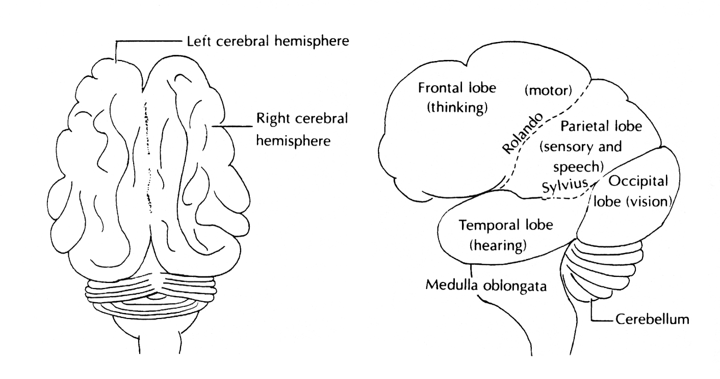
Instructions: (1.) Read the text. (2.) Use the text and the diagrams to help you to answer the questions.

Diagram A Diagram B

The brain is the control center of the body, in charge of all your mental activities and physical functions. Because of the brain's importance, the bones of the skull form a shell around it, giving it the best possible protection.
The largest part of the brain is the cerebrum. Diagram A shows that this structure is divided into two halves, the right and left cerebral hemispheres. On the surface of these hemispheres, most of the brain's work takes place.
The surface of the cerebrum is called the "cerebral cortex." Since it is only about four ¼ inch) thick, it needs a large surface area to accomplish its task; this large area is provided by folds. If you were somehow able to pump water or air into the cerebral cortex and make it expand enough to smooth out all the folds, the inflated brain would be far too large to fit inside the skull. The folds of the brain are called "gyri" (plural of gyrus"), and the grooves or furrows between the gyri are called "sulci" (plural of sulcus").
Note: While you read the following statements, look at Diagram B and observe the locations of the lobes of the brain.
Scientists use the sulci or the grooves on the cerebral cortex (called "fissures") as lines of demarcation that naturally divide the brain into lobes. The area in front of the sulcus of Rolando is called the "frontal lobe," and the region behind this sulcus is called the "parietal lobe." The line where the parietal lobe ends and the occipital lobe begins is called the "parieto-occipital sulcus." A deep fissure called the "fissure of Sylvius" separates the temporal lobe from the rest of the cerebrum.

As you can also see on the diagram, the primary functions that the different lobes control are as follows:
1. frontal lobe:
- thinking
- in front of the line of Rolando, motor—which means moving the parts of the body
2. parietal lobe:
- behind the line of Rolando, sensory—such as perception of heat, cold, pressure, pain
- b. mainly in the left hemisphere, speech
3. temporal lobe: hearing
4. occipital lobe: vision

Diagram B also shows two more parts of the brain. The tube like structure directly below the cerebrum is called the "medulla oblongata." This part of the brain does certain automatic tasks: it regulates the respiration and heart rate, for example. At the base of your skull, where your head joins the back of your neck, the medulla oblongata extends downward and becomes the spinal cord.
The second-largest part of the brain lies under the optic lobes. This part of the brain is called the "cerebellum"; it is responsible for muscle coordination. The cerebellum also helps the body to maintain its balance.
To complete this project—
Locate the indicated structures on Diagram B and color them as follows:
Level One Questions:
1. List six jobs of the brain.
2. The largest part of the brain is the _______________________________________________
3. Where does most of the brain's work take place?
4. What are the folds of the brain called?
5. What are the grooves of the brain called?

6. What are lobes?

7. Which part of the brain controls certain automatic functions such as the regulation of
breathing and heart rate?
8. The second-largest part of the brain is the _________________________________________
9. Name two jobs of the cerebellum.
Level Two Question:
10. Why does the brain have gyri? _________________________________________________
Level Three Questions:
11. The medulla oblongata can be thought of as the "automatic pilot" of the brain. Explain the reason for this designation.

12. Many people think that the brain distinguishes human beings from the lower animals. If this is so, which part of the brain is responsible for this distinction?
THE ANATOMY OF THE NEURON

Instructions: (1.) Carefully read the text. (2.) Use the descriptions to help you to label the diagram. (3.) Use the text and the descriptions to help you to answer the questions.
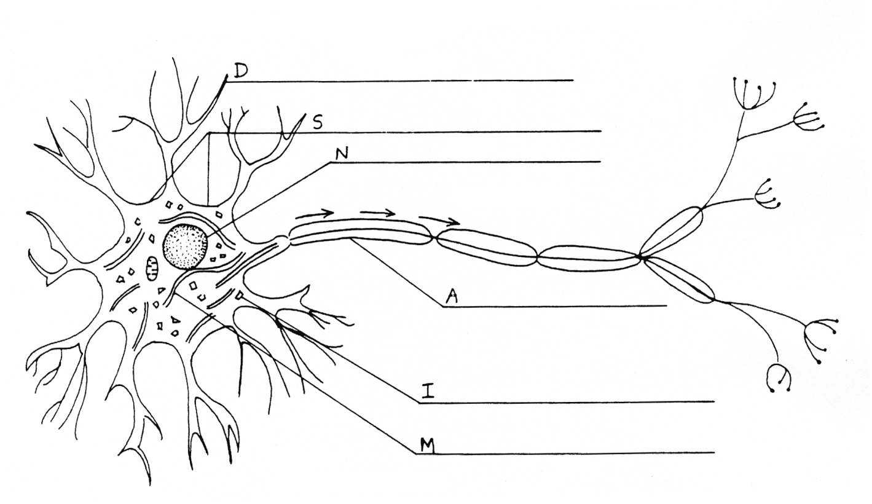

Neurons are long, threadlike cells that carry electrochemical signals. Signals from the sensory organs may be perceived by the brain as sound, sight, smell, taste, touch, or pain; signals sent by the brain to the body may cause the skeletal muscles to contract, the internal organs to operate, or the glands to release their chemicals.
In many ways, a neuron is like an electric wire. Although electric wires and neurons carry signals in different ways, their basic jobs are the same; to carry electricity. An electric wire in a radio, for example, may carry signals from a transistor to a speaker, where the signals are changed into sound. Similarly, the neurons leaving your ears send electrochemical signals to a specific area of your brain so that you can hear the sound.
While completing this project, you will learn how to name the parts of a typical neuron.

Descriptions:
- The main part of the neuron is the cell body or soma. Like other cells, the soma contains cytoplasm, mitochondria, a nucleus, and other organelles. Arrow S points to the soma, and arrow N points to the nucleus. Locate these arrows on the diagram and label them.
- Floating in the cytoplasm are irregularly shaped particles called "Nissi bodies". Scientists think that they are responsible for assembling proteins. Arrow I points to a Nissi body. Label arrow I "Nissi body."
- The cytoplasm is filled with small tubes called "microtubules." Scientists think that these tubes carry proteins and other substances through the cell. Arrow M points to a microtubule. Label arrow M "microtubule."
- The treelike structures on the soma are called "dendrites"; the term comes from a Greek word meaning "tree." Dendrites direct incoming electrochemical signals toward the soma. Arrow D points to a dendrite. Label arrow D "dendrite."
- Incoming electrochemical impulses pass through the soma and leave the neuron through a long threadlike structure called the "axon." Although axons are microscopically thin, many can reach lengths of up to three feet or more. Arrow A points to the axon. Label arrow A "axon."

Level One Questions:
1. Neurons are long threadlike cells that carry ______________________________signals.

2. When electrochemical signals are sent from the brain to a muscle, what might be the response?

3. The cell body of the neuron is also called the __________________________________

4. What do the Nissi bodies look like?

5. Scientists think that Nissi bodies are responsible for _____________________________

6. In what part of the soma are the microtubules located?

7. What do scientists think the microtubules do?

8. Where on the neurons are the dendrites located?

9. What is the job of the dendrite?

10. What is the job of the axon?

Level Two Questions:
11. The axon can reach lengths of three feet or more. In what way might this be important?

12. How is a neuron similar to an electric wire?

Level Three Questions:
13. If you look carefully, you will notice that the soma has a mitochondrion in it. What
does the presence of mitochondria indicate?

14. There are three arrows on the diagram. What do you think these arrow show?

