Name __________________________Date__________Environemental Science

Energy Flow
Every living thing needs energy to remain alive. All energy comes directly or indirectly from the sun. Green plants convert solar energy to chemical, and are therefore called PRODUCERS. They produce their own food. Animals that cannot produce their own food must eat or consume food. They are consumers. Animals that eat plants are called PRIMARY CONSUMERS. Animals that eat primary consumers are called SECONDARY CONSUMERS. Animals that eat secondary consumers are called TERTIARY CONSUMERS. The level an animal is on depends on the particular "chain" or food web it is in. DECOMPOSERS use the energy stored in once-living things and in the process, return nutrients back to the soil. Bacteria and fungi are examples of organisms that break down organisms that have died.
Food Chain -simplified look at how that energy is transferred from one living thing to another.
The arrow points to where the energy (food) is going.

SUN Grass rabbit bacteria (The sun is usually not written)
Grass rabbit bacteria

Food Web-web of interlinking (many joined) chains that shows who consumes who
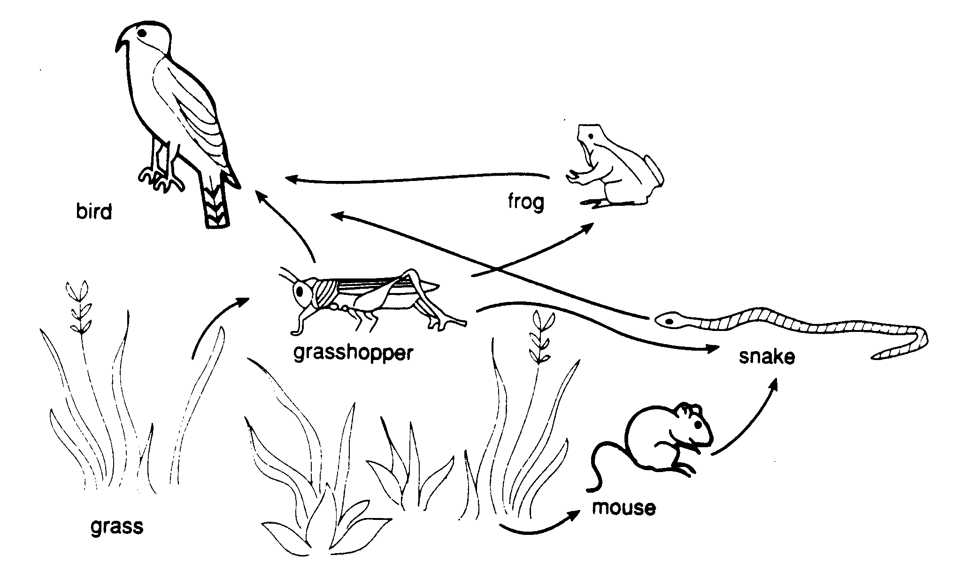

Circle all producers in the chart below.
ANIMAL | WHAT IT EATS
Stink Beetle | plants
Monarch Butterfly | leaves(as a caterpillar), nectar
Anna's Hummingbird | nectar
California Quail | insects, seeds
Brush Rabbit | green vegetation
Pocket Mouse | mostly seeds
Meadow Mouse | seeds, nuts, berries
Pocket Gopher | roots, tubers
Ground Squirrel | green vegetation, seeds, acorns, mushrooms, fruits, berries, birds, eggs, insects
Raccoon | fruits, nuts, grass, insects, bird eggs, almost anything available
Spotted Skunk | mice, birds, eggs, insects, carrion, some vegetable matter
Mule Deer | shrubs, twigs, some grass
Gopher Snake | rodents such as gophers & ground squirrels
Rattlesnake | small rodents and birds
Fence Lizard | insects
Red-tailed Hawk | rodents, rabbits, small birds, reptiles
Bobcat | small mammals and birds, carrion(untainted)
Coyote | scavenger: will eat almost anything animal or vegetable; prefers rodents, rabbits

Materials: paper, poster, markers, scissors

Procedure

Part A. Create your food chains

- Each member of the group should create at least 5 food chains on a sheet of notebook paper. You may use prior knowledge and/or the data table above. (Each food chain must start with a different producer. Each food chain must contain at least a primary and a secondary consumer). When all members of your group have 5 different food chains, raise your hand for your teacher to check.

- With his/her own food chains, each member should create a food web on his/her paper. Be sure to use ALL organisms on all 5 of your food chains. When all members of your group have your food webs done, raise your hand for your teacher to check.

Create a Food Web

- Integrate food chains from each group member to create a NEW food web on one half of a poster.

- Please use the following guidelines:
  - There must me at least 20 living things in your web.
  - There must be at least 6 producers, 10 consumers, and 2 decomposers.
  - Your food web must contain names of each living thing.
  - The arrows must point from the living thing being eaten to the living thing doing the eating to correctly represent the energy flow from one living thing to another. When you are done, raise your hand for your teacher to check.
C. Make a color code/shape code for the following: producers, herbivore, carnivores, omnivores, decomposers.
Example:
At least 6 producers
Blue circle around all producers Green diamond around all herbivores
At least 10 consumers

Red square around all carnivores

At least 2 decomposers
Orange Star around all decomposers Purple triangle around all omnivores

Underline
Primary consumers in Blue
At least 2 of each

Secondary consumers in Red
Tertiary consumers in Green

